**Lesson 1**

**AP Biology**

**Introduction/First Meeting**

**Biochemistry**

The Atomic Structure

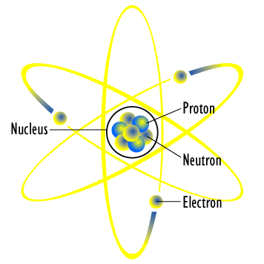

The atom is composed of a nucleus surrounded by an electron cloud. The majority of the mass is within the nucleus, which encloses the **protons** and **neutrons**. The proton is positively charged and the neutron has no charge. At certain distances from the nucleus, **electrons** that are negatively charged and relatively massless, move at the speed of light in orbitals that vary in distance from the center of the atom. These electrons contribute to how atoms will bond with other atoms forming compounds and molecules. A **compound** is two or more atoms ionically bonded together. A **molecule** is two or more atoms covalently bonded together. Bonding occurs due to the natural tendency for all atoms to achieve a perfect octet in their **valence** or outer electron shell.

**Ionic bonds** are formed by the donating or accepting of an electron. By losing an electron, the atom becomes positively charged or **cation**. If the atom gains an electron, the atom becomes negatively charge or **anion**.

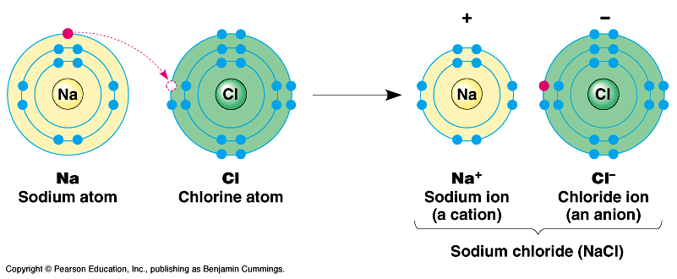

**Covalent bonds** are formed by the sharing of electrons.

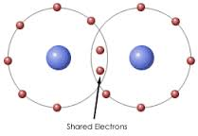

**Electronegativity** is the tendency for an atom to pull shared electron closer to itself.

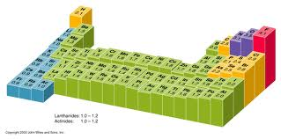

The periodic trend for electronegativity increases from bottom to top and left to right with fluorine being the most electronegative element on the periodic table. **Polarity** is when there is a presence of a highly electronegative atom that creates a slight distribution of charge within the molecule.

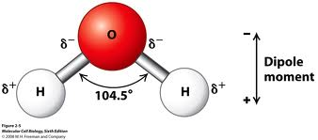

Ionic and covalent bonds are considered **intramolecular** forces and **intermolecular** forces include dipole-dipole and the van der waal forces. **Dipole-dipole** is when a polar molecule’s slightly positive atom is attracted to the slightly negative atom on another molecule. A specific example of dipole-dipole is hydrogen bonding. **Hydrogen bonding** occurs when the slightly negative atom which include Cl, F, N, or O and the lone pair of electrons on a Cl, F, N, or O atom is attracted to the slightly positive hydrogen atom of another molecule. Water is an example of hydrogen boding. Just as oppositely charged ions are attracted to one another and can form ionic bonds, the partial charges that exist at opposite ends of polar bonds can also interact with other partially charged molecules. However they are weaker in comparison because they are created through the interaction of partial charges instead of complete or full charges. If individual hydrogen bonds are so weak, then what is their significance? First, the cells of all living organisms are mainly composed of water. Because water forms hydrogen bonds with itself, other molecules that exist in the presence of water will either disrupt or interact with the hydrogen bonds formed between individual water molecules. Second, molecules essential for life such as proteins and nucleic acids possess a great capacity to form hydrogen bonds. These capabilities are essential for their function and structure. Third, while individual hydrogen bonds may not be considered strong, they are present in such huge abundance in the molecules of living organisms that their accumulated strength is tremendously significant.

